1. Created AWS EC2 Instance

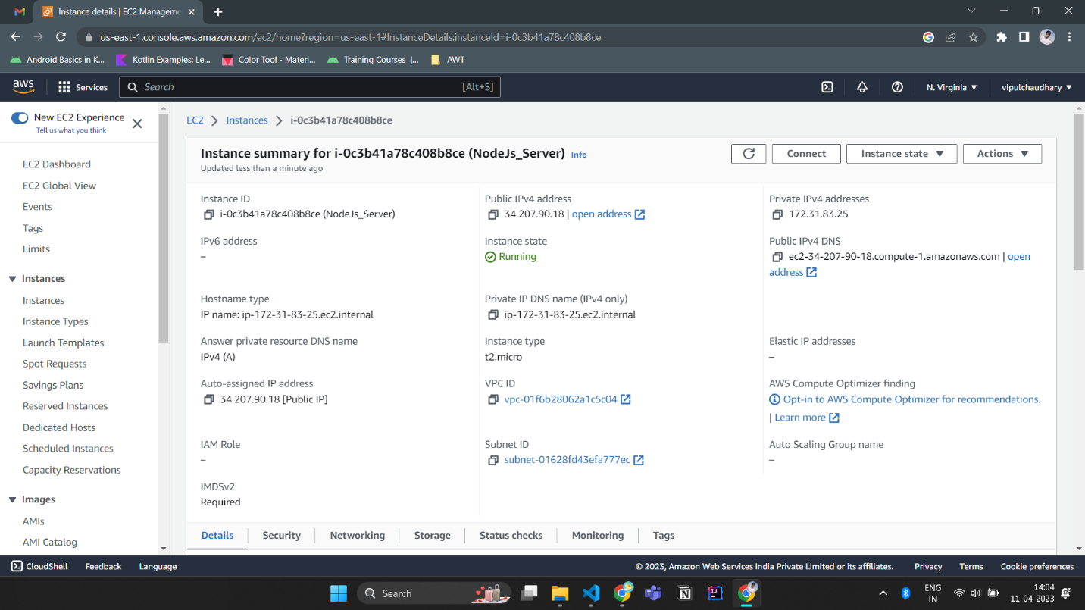

1. Connected using GitBash tool

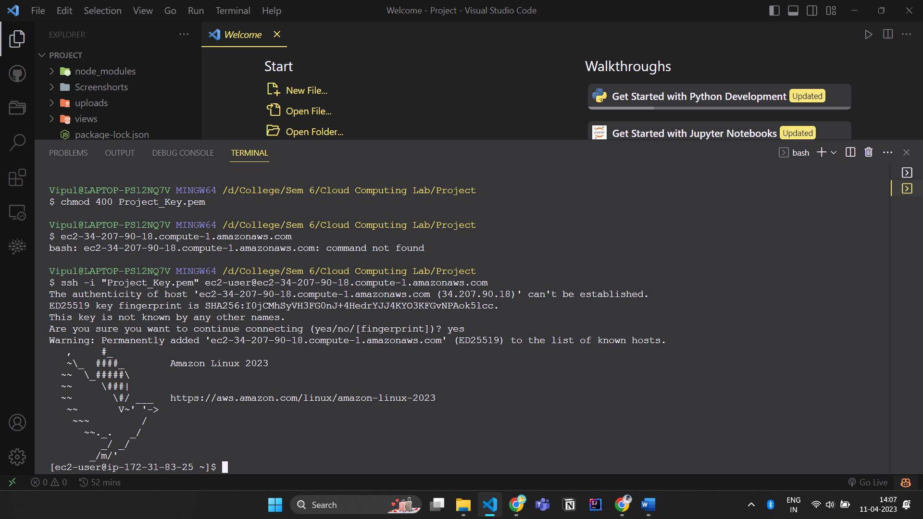

1. Create workspace folder at /home/ec2-user
2. Installed git `yum install git`
3. Installed Nodejs utilizing this docs https://docs.aws.amazon.com/sdk-for-javascript/v2/developer-guide/setting-up-node-on-ec2-instance.html